DSAA Computer Assignment – 2
Adwait Thattey
S20170010004
Sec – A

Q1. Function to make convolution:

function y = Convolution(x,h)
A = max( size(x) );
B = max( size(h) );
len = A + B - 1;
y = zeros( [1,len] );
Xe = zeros( [1,len] );
He = zeros( [1,len] );
Xe(1:A) = x;
He(1:B) = h;
for i=1:max( size(y) )
for j=1:i
y(i) = y(i) + Xe(j) .* He((i + 1) - j);
end
end
return

a)
Code to generate convolution of 2 signals:
→ Function to create x1,y1,h
function [x1, x2, h] = makex1x2h(n)
%{
x1 = {1, 2, 3, 8, 9}
x2 = {1, 0, 1, 0}
h = {1, 2, 3, 2, 1}
%}
x1 = zeros(size(n));
x2 = zeros(size(n));
h = zeros(size(n));

x1(n==0) = 1;
x1(n==1) = 2;
x1(n==2) = 3;
x1(n==3) = 8;
x1(n==4) = 9;

x2(n==0) = 1;
x2(n==1) = 0;
x2(n==2) = 1;
x2(n==3) = 0;

h(n==0) = 1;
h(n==1) = 2;
h(n==2) = 3;
h(n==3) = 2;
h(n==4) = 1;

return

→ getting y1 and y2:

clc
clear

t = -10:1:10;

[x1,x2,h] = makex1x2h(t);
y1 = convolution(convolution(x1,x2), h);
y2 = convolution(convolution(x1,h), x2);

→Verifing using inbuilt conv function

y1_inbulit = conv(conv(x1,x2), h);
y2_inbulit = conv(conv(x1,h), x2);

isequal(y1,y1_inbuilt) && isequal(y2,y2_inbuilt)

→output
logical 1

Thus Verified

b) isequal(y1,y1_inbuilt)
→output
logical 1

Thus Verified

c) Code used for plotting :
subplot(5,1,1)
stem(t,x1)
title("x1")
xticks(-10:2:10)
yticks(0:2:10)

subplot(5,1,2)
stem(t,x2)
title("x2")
xticks(-10:2:10)
yticks(0:2:10)

subplot(5,1,3)
stem(t,h)
title("h")
xticks(-10:2:10)
yticks(0:2:10)

subplot(5,1,4)
stem(y1)
title("y2")

subplot(5,1,5)
stem(y2)
title("y2")

(This image is not very clear. Image is attached in the zip folder. See that instead)
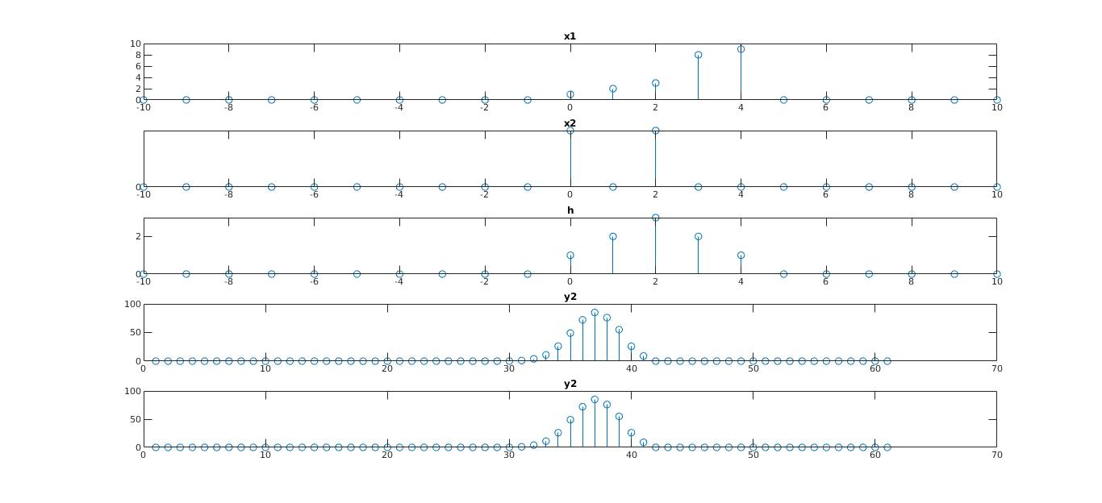
Q2)

→ Function to generate x and h :

function [x,h] = q2Func(n)
x = zeros(size(n));
h = zeros(size(n));

%{
x = {2, 3, 1, 2, 3} -> on 1
h = {1, 2, 3, 2, 1} -> on 3
%}

x(n==-2) = 2;
x(n==-1) = 3;
x(n==0) = 1;
x(n==1) = 2;
x(n==2) = 3;
h(n==-2) = 1;
h(n==-1) = 2;
h(n==0) = 3;
h(n==1) = 2;
h(n==2) = 1;
return

→ Forming y and verifing using inbuilt function

clear;
clc;

n = -10:1:10;
[x,h] = q2Func(n);

y = convolution(x, h);
y_inbuilt = conv(x, h);

isequal(y, y_inbuilt)

→ Output
logical 1

Thus Verified

b) Plotting x,h,y
→Code for plotting →

subplot(3,1,1)
stem(n,x)
title("x")
xticks(-10:2:10)
yticks(0:1:5)

subplot(3,1,2)
stem(n,h)
title("h")
xticks(-10:2:10)
yticks(0:1:5)

subplot(3,1,3)
stem(y)
title("y")

→Plot

This image is not very clear. Please also see attached image in zip folder
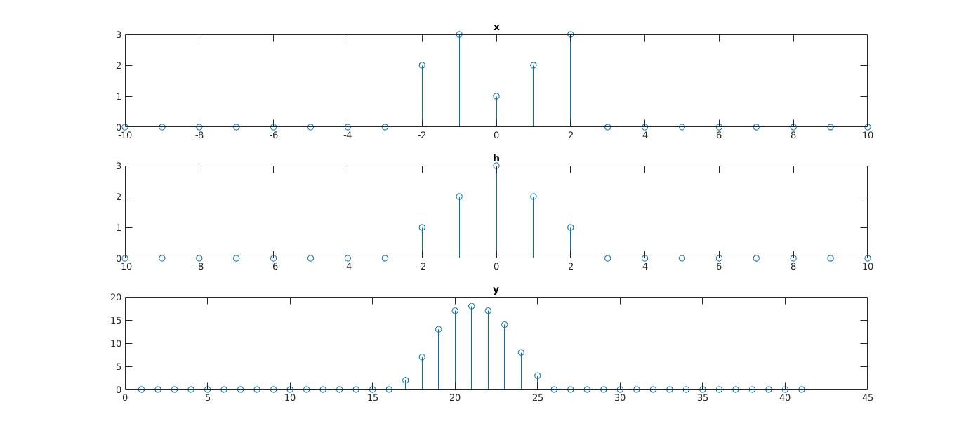

→ P.T.O.

Q3)
Function to make x and h
function [x1,h] = q3Func(n,shift1,scale1,shift2,scale2)
x1 = zeros(size(n));
h = zeros(size(n));

n1 = ( n + ( shift1/scale1 )) * scale1;
n2 = ( n + ( shift2/scale2 )) * scale2;

x1(n1==0) = 1;
x1(n1==1) = -2;
x1(n1==2) = 3;
x1(n1==3) = -8;
x1(n1==4) = 9;
h(n2==0) = 1;
h(n2==1) = 2;
h(n2==2) = 3;
h(n2==3) = 2;
h(n2==4) = 1;
return

a) Create y1,y2 and verify:
clc;
clear;

n = -10:1:10;
[x , h] = q3Func(n,0,1,0,-1);
[x1, h1] = q3Func(n,2,-1,0,1);

y1 = convolution(x, h);
y2 = convolution(x1, h1);

y1_inbuilt = conv(x, h);
y2_inbuilt = conv(x1, h1);

isequal(y1, y1_inbuilt) && isequal(y2, y2_inbuilt)
→ Output:
logical 1

hence Verified

b) → Code for plotting

subplot(4,1,1)
stem(n,x)
title("x")
xticks(-10:2:10)
yticks(-15:5:15)

subplot(4,1,2)
stem(n,h)
title("h")
xticks(-10:2:10)
yticks(-5:1:5)

subplot(4,1,3)
stem(y1)
title("y1")

subplot(4,1,4)
stem(y2)
title("y2")

The image is not very clear. A image is attached in a zip file. Please refer that too
